Name: Carmela Laya | Subject: Literacy and Mathematics
Date: July 26, 2013 | Grade Level: Integrated Pre-K (Ages 3-5)
Placement: Echo Park Early Childhood Center  ABC (Association to Benefit Children) | Description of Placement/Ratio: 18:3:1 (student:teachers:para)
Unit/Lesson Plan Format:
- Unit or Theme: Camping
  - Grade level: Integrated Pre-K (ages 3-5)
  - Class grouping: whole group, independent small group to whole group
  - Classroom staff use:
Rachel: Will sit with Madison and Nicholas during whole group and will work with small group during independent activity
Dimarys: Will sit with Evan, Giselle and Shawn during whole group and be assigned a center during small group
Tia: Will sit with Jayden and Laquan during whole group. She will be assigned a center during small group center time
Christina: Will work with Keven. She is his 1:1 paraprofessional and will sit with Kevin during whole group and small group assisting
Myself: Whole group instruction, read-aloud the “We’re Going on a Bear Hunt”, model activity and work in small groups during center time, calling one group at a time to do the activity. In small group will provide assistance and additional 1:1 instruction. After small group students will return to whole group and review the lesson
  - Student’s skill level range
During summer program students in the classroom are a wide range of ability
-Developmental age level vary between ages 3-5
  - Common Core Standards
Domain 4: Communication, Language and Literacy
Part B: English Language Arts and Literacy. Key Ideas and details:
1. With prompting and support, ask and answer about details in a text
3. With prompting and support, ask and answer questions about characters and major events in a story
Domain 5: Cognition and Knowledge of the world
Counting and Cardinality: (Count to Tell the Number of Objects)
3. Understand the relationship between numbers an quantities to 10; connect counting to cardinality a) When counting objects, say the number names in the standard order, pairing each object with one and only one number name and each number name with one and only object, b) Understand that the last number name said tells the number of objects counted. The number of objects is the same
4. Count to answer “how many?” questions about as many as 10 things arranged in a line, a rectangular array, or a circle, or as any as 5 things in a scattered configuration; give a number from 1-10, count out that many objects.
(Compare Numbers)
5. Identify whether the number of objects in one group is more, less, greater than, fewer, and/or equal to the number of objects in another group, e.g., by using matching and counting strategies (up to 5 objects).
- Goal & (Learning) Objectives of Lesson
Goal: SWBAT count and graph the number of animals in a bag and identify the greatest and the least
Objectives:
Communication:
SWBAT recall at least one of the events in the story “We’re Going on a Bear Hunt” by reciting the sounds of the text or identifying the location in the story
SWBAT verbally or nonverbally identify 2 animals that they might see during a bear hunt (i.e. bear, bugs or fish)
Cognitive:
SWBAT recognize and consecutively count the number of animals in their bag
SWBAT sort their animals in their bag and graph their animals on a graphing table
SWBAT identify the animal they had the most and the animal they had the least based on their visual graph
Fine-motor:
SWBAT grab the animals in the bag
SWBAT paste the animals in the bag on the graphing table

- Materials:
Teacher materials for read-aloud: “We’re going on a bear hunt” by Michael Rosen, poster board of the story events with Velcro, chart paper/poster board for review, maracas, rain maker, swishing paper, whistle and twigs to help read the story
Individual materials for each student: Brown paper bags, cotton balls/pom-poms, twigs, pictures of a bear, ant, duck and dog in the bag, pencils and glue. Each student will have his or her own modified graphing table
Preparation and organization prior to lesson: The poster board with sequenced events of the story, brown paper filled with cotton balls/pom-poms and pieces of twig with pictures of a bear, ant, ducks, and dogs in the bag. Each student will have their own bag, graphing table and glue
- Presentation
Introduction
- Students will engage in an interactive read aloud, “We’re Going on a Bear Hunt” by: Michael Rosen that has been read to them prior. Students will try to recall the sequence of events in the story with instruments and a visual poster board. In whole groups the teacher will say, “We have been learning all about camping, what we do when we camp and the different things we bring to go camping. Yesterday, we read, “We’re Going on a Bear hunt” by Michael Rosen. I liked this story because it used sounds to help us remember the different places the family walked to find the bear. Who can tell me where the characters in the story found the bear? Can you remember other animals the family saw during their bear hunt besides a bear? Who can name some animals that they might see besides a bear on the hunt? (Wait and write students responses) Today, we’re going to read the story again but to help us remember the story I have instruments to help us read and remember the story. (The teacher will review the instruments and sounds from the text) While we read the story I want you to put your detective eyes one and try to find other animals in the story. When you see one I want you to keep in your head until the end of the story.”
Activity
- After the read aloud students will answer, “Did you see any other animals in the story? (The teacher will list student’s answers on the board) Today, we will go on our own animal bear hunt. Each of you will get this brown paper bag. The bag will be our pretend cave, inside are different animals. You must hunt for the animals in the cave just like in the story. (The teacher will model grabbing and finding an animal in the bag). In each bag you will find different animals that you might see on your bear hunt. (Show pictures of the animals) After you find an animal in your bag your going to paste it on your graphing table. Keep going through the bag until you find all the animals and paste it on your graph. Let’s see how many animals are in my bag. (The teacher will count and graph 5 animals). I found all my animals. Who can tell me which animals I found the most? (Wait for students responses) Let’s count together. (Write number at the bottom). Which animals did I find the least? (Wait for student’s responses. Write the number at the bottom). Looking at my table I see that I had ____ the most and ___ the least.” Students will transition into center time, and the first group of students will sit at the table in the back to do the activity. The small groups will be called one by one, rotating with other centers. Each group consists of 3-4 students at a time, rotating students every 5 minutes. In small groups students will be given their brown bag caves with their graphing table. After students find an animal they must paste the animals in the corresponding column on the graphing table. When students have found all the animals in their bag, they will count the number of animals they found and circle which animal they had the most and which animals they found the least. The graphing table will be collected until whole group. During small group instruction myself and another teacher will help provide assistance to students. Each teacher will have the assessment checklist to review if students have met the objectives.
Group 1: Giselle, Donte, Shamirah & Natalya
Group 2: Christian, Casey, Abdoulaye & Dasha
Group 3: Maidson, Ralphy, Shawn & Evan
Group 4: Demani, Laquan & Brandon
Group 5: Keven, Jayden & Nicholas

Conclusion
- After students have finished finding all the animals in their bag and graphing them on a table, students will go back to the rug to do a whole group review. “How many animals did you find? How many bears, ants, dogs and ducks did you find your bag? (Ask a couple of students and write the students answers on the board). Great. Looking at your table which animals did you have the most? (Pull students graphs and ask students individually to look at their graph and record student’s answers on a large graph chart paper of the animals.) Let’s look at our graph, who can tell me which animals the whole class found the most? Which animal did they find the least? How do we know this column has the most? (Wait for students response) Let’s count together. (Write the number at the bottom. Compare the two numbers the most and the least).

Assessment/Learners’ Outcomes
*Students will be assessed with a checklist (see the sheet attached)
Adaptations
To make it easier:
- Students will count, sort and graph only 2 animals instead of 4
- Students will have animals to count from 1-5
To make it harder:
- Students will identify and count the difference between the animals found the most to the animals the least
Keven: During whole group Kevin will sit with Christina and look at different counting books. The goal is for Kevin to stay on the rug. During small group Kevin will have a modified work sheet and will work on 1:1 correspondence of a bear and a dog. Kevin’s sheet will be laminated with Velcro. He will be responsible for picking the bear and sticking it to the board.
Jayden: During whole group Jayden will sit with Tia to help to stay focus and sit on the rug. He may have an hourglass to help limit his movement. In small group, Jayden will graph and paste 5 animals, and consecutively count. He will have additional visual supports of the animals to help fill the graph.
Laquan: Laquan can be hyperactive and easily distracted. He will be allowed to bring one toy to the rug and sit with Tia during whole group instruction. In small group, he will graph and find 8 animals
Nicholas: Will sort, count and graph 10 animals
Evan: Evan is hyperactive and tends to move around on the rug. Evan will sit with Demaris. He will count, paste and graph 10 animals.
Madison: During whole group she will sit with Rachel. She will sit in her adapted “special” chair during circle time. During small group she will identify 8 animals and paste them on the graph.
Shawn: Will sit with Dimarys and will paste 5 animals on the graph.

Assessment
How did you determine what to teach?
The class has been focusing on the unit on camping. I wanted to incorporate a math lesson with camping because the teacher had other lessons focusing on the social studies lessons of camping, such as what families do during camping, what equipment they might need for camping and what kind of activities (i.e. making smores or canoeing). The teacher suggested a mathematics or literacy lesson associated with camping. Due to the wide range of developmental levels in the classroom I felt that counting was an easy way to assess students knowledge, and easily modified for children’s learning needs in the classroom.
How is mastery/achievement/understanding determined?
To understand the achievement of the lesson I evaluated the student’s learning abilities in the classroom and reviewed the common core to determine which standards could be successful.
What will you teach next?
For the next activity, students could practice sequencing the events of the story and do a writing activity of which animals they would like to find during a hike. Students will illustrate a picture and practice writing what they like to do during a bear hunt.

 | Students participated during whole group and recited the sounds of the text during read-aloud | Verbally or nonverbally identified 2 animals that they might see during a bear hunt | Recognize and consecutively count the number of animals in their brown paper bag | Correctly sorted and graphed the animals in their bag on their graphing table | Identify the animal they had the most and the animals they had the lease based on the table graph | Students correctly grabbed, pasted and graphed the animals on the graphing table
1. Madison
2. Keven
3. Jayden
4. Nickolas
5. Laquan
6. Demani
7. Evan
8. Giselle
9. Shamirah
10. Donte
11. Abdoulaye
12. Casey
13. Christian
14. Dasha
15. Ralphy
16. Shawn
17. Natalya
18. Brandon
*Students will be evaluated on a 1-4 scale
1: Student did not meet the objective
2: Student is approaching to meet the objective
3: Student met the objective
4: Student exceeded meeting the objective
n/a: Not applicable

10
9
8
7
6
5
4
3
2
1
 | 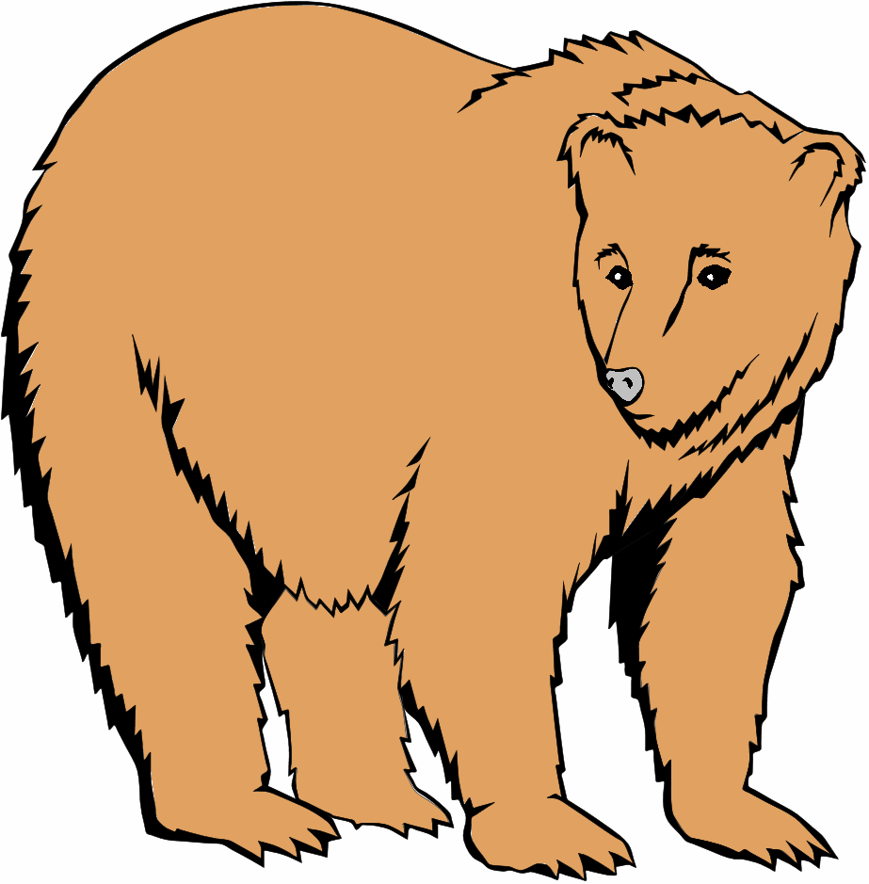 | 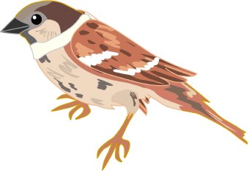 | 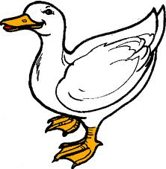 | 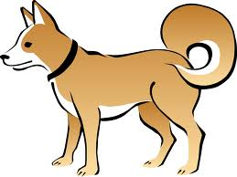

SELF-EVALUATION OF SUPERVISED OBSERVATIONS:
Please look over the Key Areas & Skills Summary Sheet to review the areas that will be evaluated by supervisors during your observations and consider these areas when reflecting upon your performance. The purpose of this evaluation is to help you become more reflective in your practices, and to help you learn how to critically evaluate your performance in order to identify areas of strength and areas that need to be further developed. In addition, this information will be extremely useful for supervision, as your supervisor will be able to provide you with more specific support and guidance in the areas that you feel are in need of further development.
Each candidate is expected to complete this self-evaluation after every supervised observation (including the video). Please keep 1 copy to submit for your portfolio at the end of the semester, and provide a copy to your supervisor.
- What do you think went particularly well with the lesson/activity?
What went well this lesson was my energy and interaction with the students. I wanted to ensure that I exuded a positive and energetic personality with clear instruction to support students’ engagement during the lesson. I think the instruments provided a creative alternative way of telling the story, which supported class involvement. Since the instruments can be found in most households, it was a great way to include music into the lesson. I distributed the staff in the classroom according to the students’ needs and strengths. There was great collaboration between staff members that made the lesson run smoothly. Considering the students learning styles and needs by deciding to do small group during center time allowed students’ to make choices. This helped limit the behavioral challenges that could have occurred if students were sitting for to long doing one activity.
- Describe 1 or 2 skills that were demonstrated during the lesson that you feel were particular areas of strength for you.
A skill that was demonstrated during the lesson was my engagement and energy with the students. I felt that my execution was supported with providing clear language and positive reinforcements for students that participated during the lesson. I provide a variety of opportunity for the different learners in the classroom to be successful and be engaged with instruments, active involvement in the modeling and ask questions.
- What areas or specific skills do you feel you still need to develop or improve upon for future lessons? What skills that were demonstrated during the lesson do you feel are an area of difficulty for you, and an area that you would like to continue to work on during the semester?
In the future I need to develop better transitional skills for the students between centers. I want to improve my verbal, visual and prompting for students to identify the time allotted for each center activity. I need to have better time management with the amount of time for whole group and small group instruction. Specific skills I need to develop are my teaching instruction by improving my directions and modeling for students. Even though many of the students had understanding of the expectations and directions of the activity, many students showed confusion about counting the animals on the graph. I need to learn to provide clearer instructions in a shorter amount of time. Hopefully cutting the time on the rug in half, which will allow students more time for the activity and centers. During my instruction I could use more motivational language to help students stay focus. The most difficult skill to demonstrate was my transitions and classroom management. Although students behaved well during my instruction, in the future I would like to improve my management by being prepared for the different behavioral challenges that could occur throughout a lesson. I was fortunate to have staff that helped to manage the different disabilities in the classroom. In the future I want to provide more structure and create boundaries that will help students to stay on task. Another skill I want to continue to strive and progress is being more flexible when things do not go according to plan.
- Please describe any other thoughts or concerns about your observation:
Some of my concerns were my timing and the students’ ability to do the activity. I was concerned that students would not understand the lesson and instruction. I felt that I could have better improved my transitional skills and management of the class. With my teacher observer we discussed alternative ways that I could have divided the group instruction. We both agreed that I over planned and might have expected too much in one lesson. I was worried that the other two centers would pose as a distraction for the center activity and students would be less motivated to do the activity.

