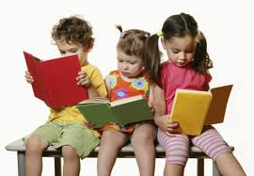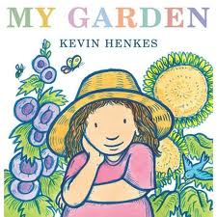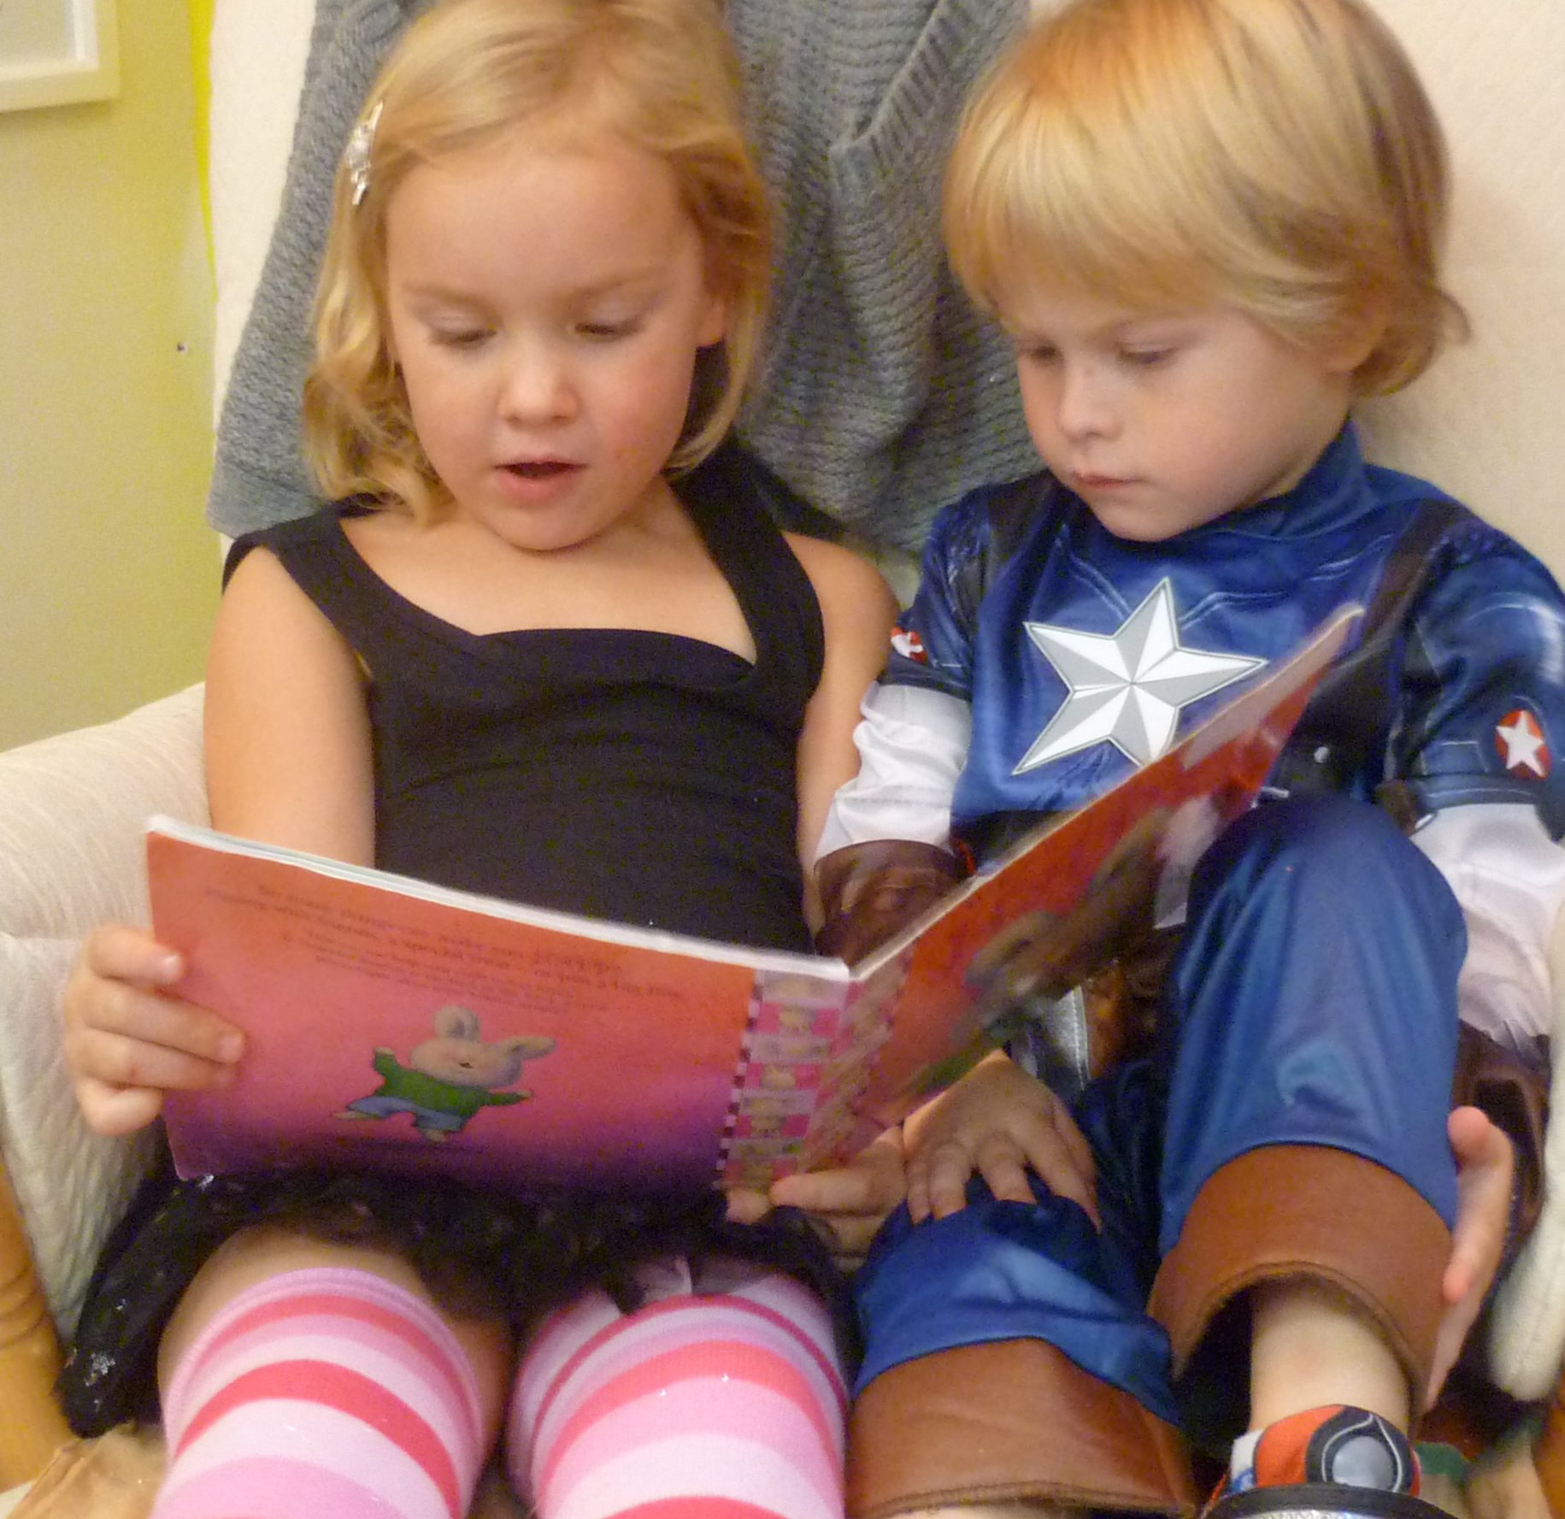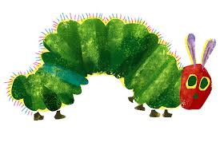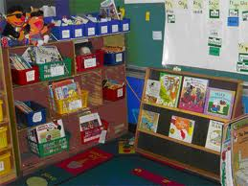

Support literacy at home by reading books and encouraging your child to ask questions. Reading to your child even for 5 minutes everyday will help increase your child’s love and interest in reading. Reading to your children is a simple and easy way to spend quality educational fun with your child.

**Suggested Reading Tips:**

* Make reading fun by acting out characters with your child
* Review the roles of an author, illustrator
* Ask –wh questions of who, what, where, and why to increase comprehension
* Do picture walks together by discussing what you see in pictures

Families can come be a part and participate in publishing our spring class book

Children will share their class stories and quick tips of how families can incorporate literacy at home

# Literacy at Home

Welcome Families,

Spring is fast approaching and we will start our spring unit that will focus on plants, seeds, food, weather and caterpillars. In our spring unit our class will explore how plants grow, the different types of seeds, the different types of weather and the metamorphosis process of caterpillars. Please review the following upcoming events .

Class Newsletter

Ms. Laya’s Kindergarten Class

Have your child bring something they like to do in spring

April 10

April 17

April 25

##### Show and Tell

##### Publishing Party

##### Literacy Night

# Spring is Here

#### Save the Date!

### the

In our classroom we support literacy by providing enriching activities, literature and games to help emerging readers value and love reading. Building a strong reading foundation when children are young increases children’s love for reading. Better readers’ increases academic success in not just reading and writing, but in all subject areas.

Incorporating Literacy in the Classroom

* “The Hungry Caterpillar” by: Eric Carle
* “Isabella’s Garden” by: Glenda Millard
* “And Then It’s Spring” by: Julie Fogliano and Erin E. Stesd
* “My Garden” by: Kevin Henkes

**-at (cat, bat, mat)**

**-un (sun, bun,fun)**

**-flower**

**-seed**

Cite Words this Month

This month we will review the roles of an author and illustrator and basic book concepts (i.e. cover, title, cover page). We will take picture walks to encourage children to make predictions and use picture cues to help read the stories. To increase comprehension skills, children will recall who, what, and where with picture sequencing cards.

Reading Concepts

###### “The more that you read, the more things you will know. The more that you learn the more places you'll go.” –Dr. Suess

# Literacy in April

## Books we will read this month

Some literacy center activities include:

* Site word bingo game
* Word stacking using blocks and cards
* Popsicle comprehension sticks
* Memory site word game
* Caterpillar building words
* Mystery letter bags

Have a wonderful day!

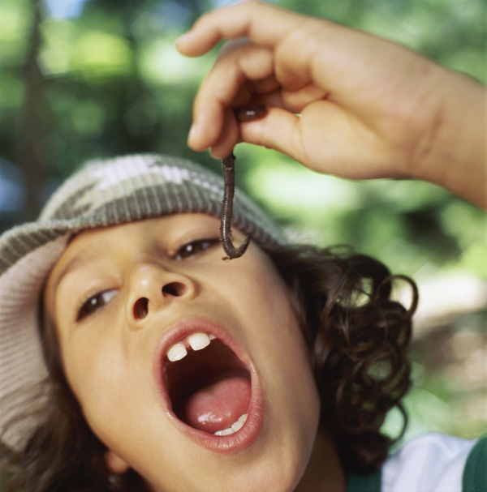

**BOOK FAIR!!!**

**MAY 1ST**

-Please have your child bring money in a sealed envelope to bring to the book fair. Students will get tokens to buy books.

APRIL 2013

Literacy Center Activities

Ms. Laya’s Kindergarten Class

**Please feel free to email or talk to me after-school for additional questions or information**

***Additional Dates to Remember***